**The Cleveland Museum of Natural History Reduces Business Hours in Response to COVID-19 Surge**

**FOR IMMEDIATE RELEASE**—The Cleveland Museum of Natural History has announced that, in an effort to keep the Cleveland community safe, it will temporarily reduce its operating hours to Fridays, Saturdays, and Sundays through December 31, 2020. The new hours will take effect immediately.

“This is not a decision we made lightly,” says Sonia Winner, the Museum’s President & CEO. “We are taking this precautionary step to do our part to help slow the virus’s spread and to ensure the health and wellbeing of our community.”

Celebrating its centennial in just a few short weeks, the Museum will debut a new, limited-time exhibit, *Wildlife Rescue: Miracles in Conservation*, on Friday, November 27, 2020. In an effort to mitigate excess foot traffic throughout this space, the Museum will offer Member Mornings on Friday, November 27, and Sunday, November 29, to allow members to view the new exhibit an hour earlier than the general public.

“The Museum’s continuity as a pillar for learning is immeasurably important during these trying times,” says Winner. “The benefits of building a connection with nature are plentiful and we aim to provide ongoing opportunities to forge that relationship.”

The Museum will be closed on Thursday, November 26, for Thanksgiving and Friday, December 25, for Christmas. The community is encouraged to engage with the institution through its robust collection of online programming. These virtual offerings include the now-virtual Explorer Lecture Series, brand-new Discover E events, and trivia games for all ages.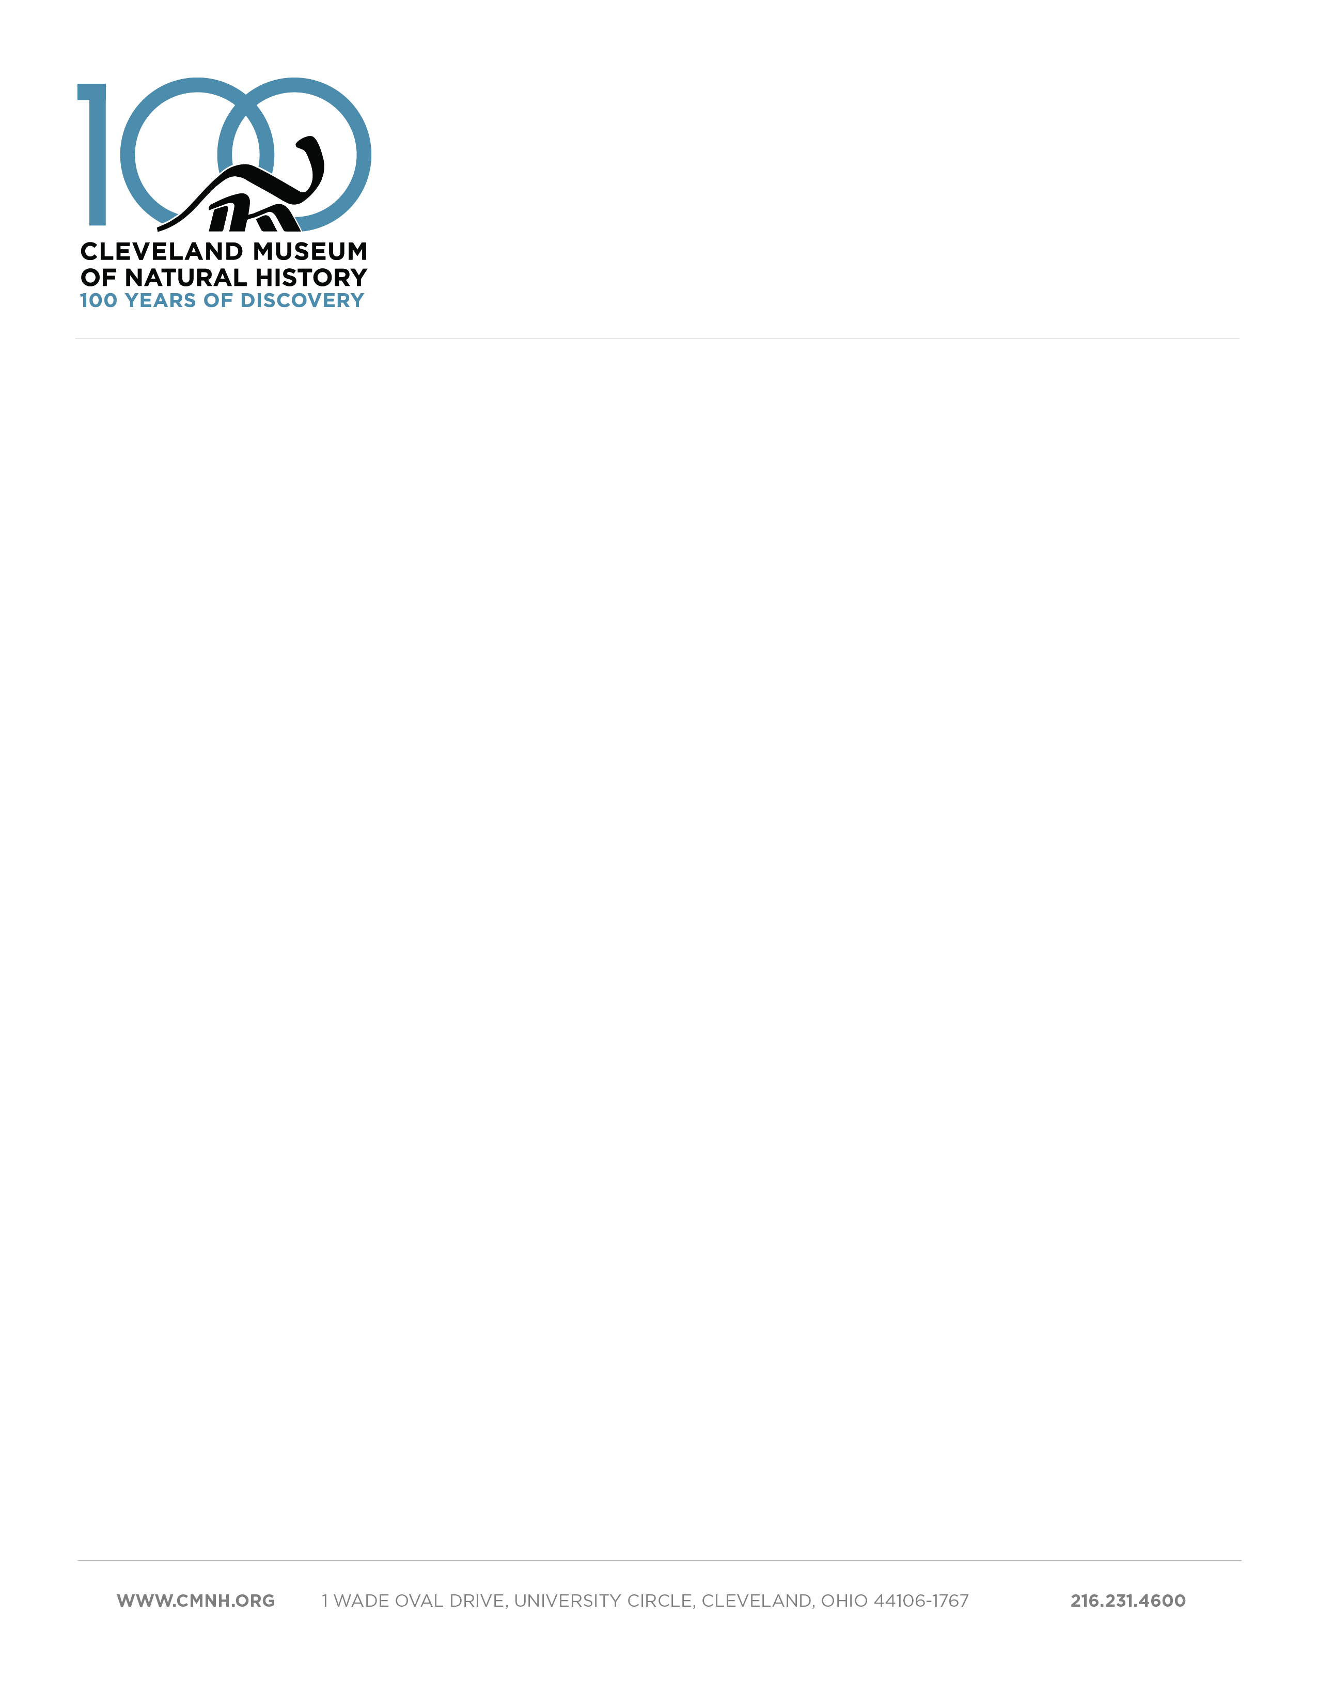

**About The Cleveland Museum of Natural History**

For nearly 100 years, the Cleveland Museum of Natural History has been recognized as a global leader in scientific research. With vast collections containing more than 5 million research specimens and artifacts, it is Ohio’s largest museum devoted to the natural sciences and one of the top natural history museums in the United States. The Museum’s renowned curators conduct world-class research, advancing the frontiers of scientific knowledge by making groundbreaking discoveries and contributing to top peer-reviewed journals and publications.

A cornerstone of the Museum’s mission is science education. The discoveries we make every day enrich and enhance our educational programs for learners of all ages. At the Museum, you’ll have the opportunity to delve deep into the past in our dinosaur hall, discover the outer reaches of the Universe in the [Shafran Planetarium](https://l.facebook.com/l.php?u=https%3A%2F%2Fwww.cmnh.org%2Fvisit%2Fplanetarium-observatory%3Ffbclid%3DIwAR3FZJQIaje83HersN3xt8MRRDxnSQFwPFn94SLzC8hsshhKruN-lm2L_kM&h=AT3EThH-w3RfbpmDj4vYzRzE0gAIgM9DnHakzQwR_yRH9AU9679ef-OfV0ZJ1FL6BBgWtkWdX_sjyUn5ETQByzekZlLasgK4FIA-BZRtq-NpDFlkzLZzay-9u9Eqjf2Bwfkq-OAs), and experience natural wonders in [outdoor galleries](https://l.facebook.com/l.php?u=https%3A%2F%2Fwww.cmnh.org%2Fvisit%2Fwildlife%3Ffbclid%3DIwAR2wL8Ar5kSq5OAHTAtLJki3a6AZlgUHzMI4qhhPxvkIko7ZUtHj59R5fOM&h=AT27KlTK2de-0dJqojCH3nP2JgAby2r4rvBqk_GG6Wq4HhwiCjmsmaqeI-uIHCVAhgHIsMYTwDpBvXkk6Fgd4y2KldEyoSF_OknHNzVLk4WIb69Vr-1K_taxeDrJs6VhI7vuO9Fb). Our talented educators help curious minds forge connections with science and nature.

Beyond the Museum campus, we protect almost 11,000 acres through our [Natural Areas](https://l.facebook.com/l.php?u=https%3A%2F%2Fwww.cmnh.org%2Fnatural-areas%3Ffbclid%3DIwAR3mBCIYL50oMtVtaGkHUbr4XJkluVI4GuyWW_lZxXonCcFHAZeF_5LiJ3E&h=AT00bv0vbU79k5p9tYLgHNCgjwPTXbcuMrsnKU9MnLUmCnrIs9qynv9gi-tHu-NZy-k4sFjPFVTl0wJwuSk4BJudeCxrbLZdm6fG9Qa4GMFo_XNGKkz9TJrYZqj7VNIP7-p8n8qZ) Program. Each preserve harbors at least one unique natural community, such as hardwood forest, Lake Erie island, fossil dune ridge, marsh, swamp, or glacial wetland. Representing the remarkable biological diversity that was once widespread throughout the region, these areas now serve as educational scientific resources.

**Our Mission**

To inspire, through science and education, a passion for nature, the protection of natural diversity, the fostering of health, and leadership to a sustainable future.

**Our Vision**

To explore, engage, and empower for a better tomorrow.

**Connect with the Museum**

Website: www.CMNH.org

Facebook: @theCMNH

Instagram: @gocmnh

Twitter: @goCMNH

YouTube: https://www.youtube.com/user/TheCMMN